- Which of the following quantities is not derived from the base quantity of ‘length’?
A. weight
- velocity
- acceleration
- mass

2. Which of the following arrangements of prefixes is in descending order?
A. micro, deci, centi, mega
B. mega, kilo, centi, micro
C. centi, kilo, micro, Mega
D. mega, centi, kilo, micro

3. The diagram shows two pulses on the screen of a cathode ray oscilloscope. A grid of 1 cm squares covers the screen. The time base setting is 1 μs cm^{–1}.
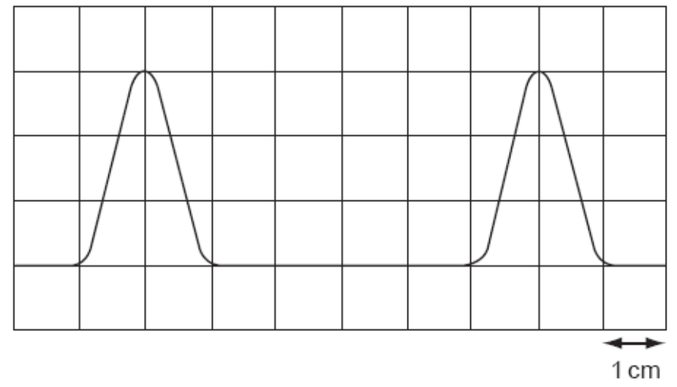
How long does each pulse last?
A. 2 μs B. 3 μs C. 4 μs D. 6 μs

- In an experiment, a radio-controlled car takes 2.50 ± 0.05 s to travel 40.0 ± 0.1 m. What is the car’s average speed and the uncertainty in this value?
- (16 1) ms⁻¹
- (16.0 0.2) ms⁻¹
- (16.0 0.4) ms⁻¹
- (16.00 0.36) ms⁻¹

- Which of the following quantity is scalar quantity?

- Force
- Gravitational potential energy
- Torque
- Momentum
- A stone is projected at an angle of 20° with the horizontal at a speed of 40 ms⁻¹. What is the horizontal component of the velocity of the stone when it has reached maximum height on its way up?

A. 37.6 ms⁻¹ B. 18.8 ms⁻¹ C. 13.7 ms⁻¹ D. 6.9 ms⁻¹

  - A piece of brick with a mass of 2 kg is dropped from a height of 20 m from the ground. What would be the velocity and momentum of the brick just before it hits the ground?

Velocity / ms⁻¹ Momentum / kg ms⁻¹
A. zero zero
B. 10 20
C. 20 40
D. 20 800

- In the figure below, a ball of 2 kg mass travels up a smooth slope with an initial velocity of 4 ms⁻¹. What is its velocity at B?

2 kg
60 cm
4 ms⁻¹
smooth slope
B
A
A. 0 ms⁻¹ B. 1 ms⁻¹ C. 2 ms⁻¹ D. 4 ms⁻¹

4 N
3 N
5 N

The figure above shows a system of forces. The resultant force of the system is
- 0 N
- 5 N
- 12 N
- 25 N
- A body is launched vertically upwards from the ground. It reaches a maximum height and then falls back to the ground. If the air resistance can be neglected, the physical quantity which remains constant throughout the whole journey is

- Resultant force
- Velocity
- Momentum
- Kinetic energy

- A particle moves along a straight line. A particular property K of the particle's motion is plotted against time.
K
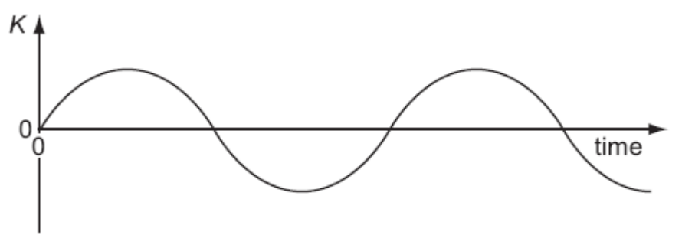

time

At any time, the slope of the graph is the acceleration of the particle.
What is the property K?

A. the displacement of the particle
B. the distance travelled by the particle
C. the speed of the particle
D. the velocity of the particle

- The diagram shows two blocks of wood of masses m₁= 5.0 kg and m₂ = 3.0 kg in contact with each other on a smooth horizontal floor. A force as 12.0 N is applied as shown. What is the force with which m₁ is pushing m₂?

m₁=5.0kg
m₂=3.0kg

12.0 N

A. 4.5 N B. 6.0 N C. 7.2 N D. 7.5 N

- To travel at a constant speed, a car engine provides 24 kW of useful power. The driving force on the car is 600 N. At what speed does it travel?

A. 2.5 ms^{–1}
B. 4.0 ms^{–1}
C. 25 ms^{–1}
D. 40 ms^{–1}

- A metre-rule is pivoted at its centre of gravity. Equal and opposite forces of magnitude 1.5 N are applied at the 40.0 cm and 60.0 cm mark on the metre-ruler. What is the magnitude of the torque of the couple on the metre-rule?

1.5 N
1.5 N
60°
60°
A. 0.26 Nm B. 0.6 Nm C. 1.5 Nm D. 30 Nm

- The figure shows two trolleys, X and Y approaching each other. The momentum of each trolley before impact is as shown. After collision, the trolleys travel in opposite directions and the momentum of trolley X is 2 kg ms⁻¹.
X
Y
10 kg ms⁻¹
6 kg ms⁻¹

What is the magnitude of the momentum of trolley Y?
A. 2 kg ms⁻¹
B. 4 kg ms⁻¹
C. 6 kg ms⁻¹
D. 14 kg ms⁻¹

- Car P is travelling at double the speed of car Q. Car P has half the mass of car Q. Which statement is correct?

A. Car P has half the kinetic energy of car Q.
B. Car P has one quarter of the kinetic energy of car Q.
C. Car P has twice the kinetic energy of car Q.
D. The two cars have the same kinetic energy.

- The table summarises some properties of evaporation.
Which row of the table is correct?

 | Involves a change in state from liquid to vapour | Occurs at a fixed temperature | Involves a reduction in the average kinetic energy of the remaining atoms
A. | true | true | true
B. | true | false | true
C. | true | false | false
D. | false | true | false
- Pollen grains are suspended in a liquid and are illuminated strongly. When observed under a microscope they are seen to be in continuous random motion.
What is the reason for this?

A. convection currents in the liquid
B. evaporation of the liquid
C. molecules of the liquid colliding with the pollen grains
D. pollen grains colliding with each other

- The behaviour of a wire when it is extended by a tensile force is represented by the graph of the stress against strain as shown below.
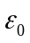
Stress
Strain
W
X
Y
O
Which of the following is false ?

A. the shaded area below the straight line OW is the same as strain energy per unit volume.
B. Young’s modulus for the material of the wire is the same as the gradient of the straight line OW.
C. a permanent deformation 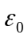 is produced when the stress exerted on the wire at the point X is removed.
D. point X is ultimate tensile stress.

- Nylon breaks when the stress within it reaches 1x 10⁹ Pa.
What is the heaviest load that could be lifted by a nylon thread of diameter 1 mm?

A. 1 x 10² N
B. 1 x 10⁸ N
C. 8 x 10² N
D. 8 x 10⁸ N

- What is the relationship between the intensity I and the amplitude a of a wave?

- I α 1
a

- I α a

- I α a²

- I² α a

- An electromagnetic wave has a frequency of 10¹⁹ Hz.

In which region of the electromagnetic spectrum does the wave occur?

- infra-red
- radio
- ultraviolet
- x-rays

- Which of the following phenomena does not depend on superposition of waves?

- polarization
- interference of sound
- interference of light
- stationary waves

- The slits in a diffraction grating are separated by 1.6 x 10⁻⁶ m. When a parallel beam of monochromatic light is shone on the grating, a second order maximum is produced at 32º to the direction of the undeviated beam.

What is the wavelength of the monochromatic light?

A. 210 nm B. 270 nm C. 420 nm D. 840 nm

- Light of wavelength 600 nm falls on a pair of slits, forming fringes 3.00 mm apart on a screen.

What would the fringe spacing become if the wavelength were 300 nm?

A. 0.75 mm B. 1.50 mm C. 3.00 mm D. 6.00 mm

- Which diagram shows the electric field pattern of an isolated negative point charge?

A. B. C. D.
-
-
-
-

- What is an equivalent unit to 1 volt?

A. 1 J A⁻¹ B. 1 J C⁻¹ C. 1 W C⁻¹ D. 1 W s⁻¹

- An electrical component has the following circuit symbol.

What does this symbol represent?

- variable resistor (rheostat)
- fuse
- light-dependent resistor
- thermistor

- A potential difference V is applied between two parallel plates a small distance d apart, and produces an electric field of strength E between the plates.

V d

What is the electric field strength between the plates when both V and d are doubled?

A. E / 4 B. E C. 2E D. 4E

- The resistance of a device is designed to change with temperature.
What is the device?

- a light-dependent resistor
- a potential divider
- a semiconductor diode
- a thermistor

- A copper wire of cross-sectional area 2.0 mm² carries a current of 10 A.
How many electrons pass through a given cross-section of the wire in one second?

A. 1.0 x 10¹ B. 5.0 x 10⁶ C. 6.3 x 10¹⁹ D. 3.1 x 10²⁵

- The filament of a 240 V, 100 W electric lamp heats up from room temperature to its operating temperature. As it heats up, its resistance increases by a factor of 16.
What is the resistance of this lamp at room temperature?

A. 36Ω B. 580Ω C. 1.5 kΩ D. 9.2 kΩ

- Three resistors are connected in series with a battery as shown in the diagram. The battery has negligible internal resistance.

12 Ω

12.0 V 18 Ω

15 Ω

What is the potential difference across the 18 Ω resistor?

A. 3.2 V B. 4.8 V C. 7.2 V D. 12.0 V

- The diagram shows a light-dependent resistor (LDR) and a thermistor forming a potential divider.

+

−

Under which set of conditions will the potential difference across the thermistor have the greatest value?

 | illumination | temperature
A.  B.  C.  D. | low  high  low  high | low  low  high  high

- Which electrical quantity would be the result of a calculation in which energy is divided by charge?

- current
- potential difference
- power
- resistance

- In the α-particle scattering experiment, α-particles are directed towards a thin gold film. Most of the α-particles pass through the film with very little deviation, but about 1 in 8000 is deviated through an angle greater than 90º.
For what do these observations provide evidence?

- that gold has several isotopes
- that there are α- particles of different types
- that there are large spaces between atoms in the gold film
- that nuclei occupy very small volumes within atoms

- What is a correct order of magnitude estimate for the diameter of a typical atomic nucleus?

A. 10⁻¹⁴ m B. 10⁻¹⁸ m C. 10⁻²² m D. 10⁻²⁶ m

- Which two nuclei contain the same number of neutrons?

- 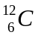 and 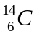
- 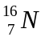 and 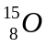
- 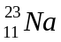 and 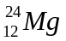
- 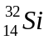 and 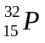

- Which statement concerning α- particles is correct?

- An α-particle has charge + 4e.
- An α-particle is a helium atom.
- When α- particles travel through air, they cause ionization.
- When α- particles travel through a sheet of gold foil, they make the gold radioactive.

- When a nucleus of 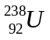 absorbs a slow neutron it subsequently emits two β-particles.

What is the resulting nucleus?

A. 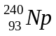 B. 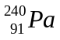 C. 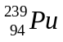 D. 